**Your name  
Teacher’s name, Class**

*Title of Book*

**Author: Name  
Type of book: Enter type of book here**

## Introduction

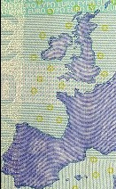Give an overview of the book, indicating what the focus of your book report will be. You can replace the picture on the right with a picture of the cover of the book.

## Author

Outline the author’s life, focusing on the timeframe that includes the writing of this book.

## Main characters

|  |  |
| --- | --- |
| Character One | Describe this character. |
| **Character Two** | Describe this character. |
| Character Three | Describe this character. |
| Character Four | Describe this character. |

## Story

Break the book down into a logical number of sections. This example shows “Beginning,” “Middle,” and “End,” but books often have many more relevant sections.

## Themes

Describe the theme(s) of the book.

## Evaluation

Make your main points here. Evaluate the book. Draw your conclusions.